Hestia War Room Enhancements Deploy Guide

Revision History
Author | Revision Number | Date
TCSASSEMBLER | 1.0 | 08.05.2013

Deployment Instructions 3
1. Organization of Submission 3
2. Application Setup 3
2.1 Build Scripts Setup 3
2.2 Configuration Files 3
3. Database Setup 4
4. Deployment Instructions 4
5. Starting 4
5.1 Data Load Tool 4
5.2 Web Application 5
6. Verification 5
6.1.1 Save all and Undo 5
6.1.2 My Pricing 8
6.1.3 Lowest Net Price 9
6.1.4 Saved Filter 11
6.1.5 UI Updated 12
6.1.6 Adjustment 13
7. Resource Contact List 13

Deployment Instructions

Organization of Submission

Submission builds on top of the existing repository structure at

https://coder.topcoder.com/tcs/clients/hestia/applications/WarRoom/trunk/code

Application Setup

- Java 1.6
- JBoss 6.1.0Final
- Oracle 11g
- Apache POI 3.9

Build Scripts Setup
hestia/build.properties – listed here are the properties that you may need to modify to properly run the compilation and deployment of the application.

jboss.home – replace with the path of your JBoss 6 installation
@logout.url@ - the URL should be updated with the correct environment details

The following properties are related to DB connectivity and should be updated if needed:
db.driver, db.pass, db.url, db.user, @ds.jdbc.driver@, @ds.jdbc.pass@, @ds.jdbc.url@, @ds.jdbc.user@

The configuration of db in ExcelToDB\test_files\db.properties should be modified to fit your environment.

Note: Other properties can be left as is.

Configuration Files
There were no new properties added for this assembly. The new actions were updated on hestia_war_room.properties for authorization

Database Setup
Setup your Oracle installation and create the tables and sequences by running hestia/conf/sql/createTables.sql or clear the environment with hestia/conf/sql/dropTables.sql

Note: DB can also be setup using the ant targets “db-create”, “db-drop”

Deployment Instructions

- Checkout from Revision 231496from SVN
- Extract the contents of the submission on top of the svn code.
- Modify the build properties as specified in #2.1.
- Setup the DB as specified in #3.
The following next steps can be run automatically by running “ant -f build.xml deploy-jboss-config”
- Copy the datasource info from hestia/conf/oracle-ds.xml to {JBOSS}/server/default/deploy. (don’t forget to modify the info in oracle-ds.xml with your environment info) (make sure all properties are replaced with correct values)
- Copy hestia/conf/hestia_war_room.properties to {JBOSS}/bin. (make sure all properties are replaced with correct values)
- Copy ojdbc driver to {JBOSS}/common/lib. (hestia/lib/third_party/oracle/ojdbc14.jar is included in the submission but this may differ depending on the version you’ll test against).

To build the application: (from hestia folder)

ant -f build.xml deploy

Starting

Data Load Tool

You can use Eclipse to create the project and load the whole ExcelToDB project and set the necessary reference jars. then you can run the ReadExcelToDBTableTool in GUI freely.

Or you can run “ant run” to compile the data tool source, generate the jar and run the jar. Note, before running the ant, you should locate the POI3.9 and jdbc driver of oracle jars in test_reflib folder.

Web Application

The web application is started when the application server starts

Verification

You MUST run the data load utility before testing, it will insert the test users and test data from the included excel worksheet. Refer to section 5.1, or the deployment guide of the search assembly (“Deployment Guide”, the document is provided in the repository in hestia/docs

After deployment, open the site in your browser: http://localhost:8080/hestia (host and port may vary, depending on your JBOSS installation.) And log in as user/pass, ( it may be user/WRuser321)

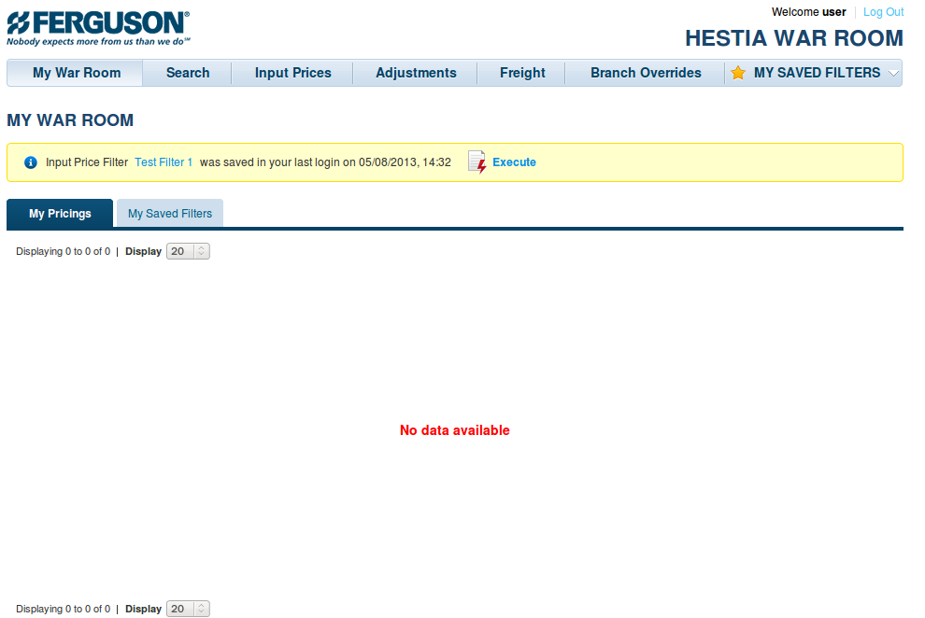

SaveAll and Undo
  - Let's change some data
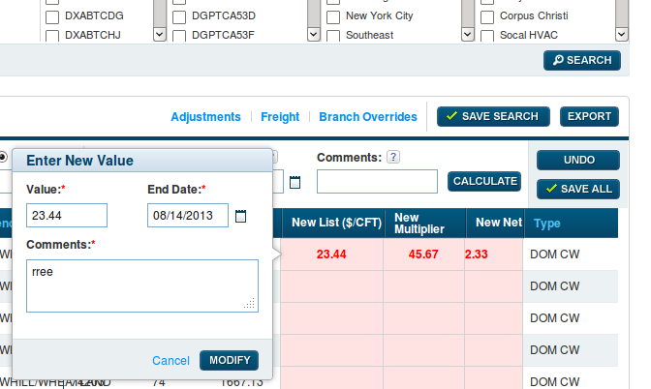
  - If you click 'Save All'
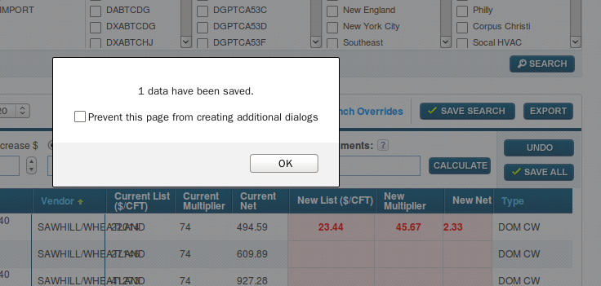
  - Wait for a moment to load page, then you can see 'Current List' and 'Current Multiplier' have changed as you input
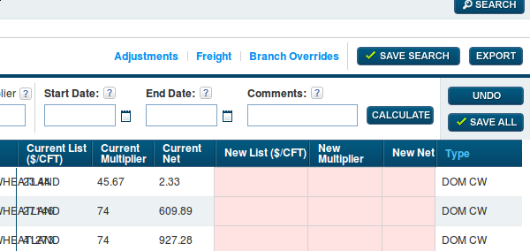

Let's input some data to verify 'Undo' funcation
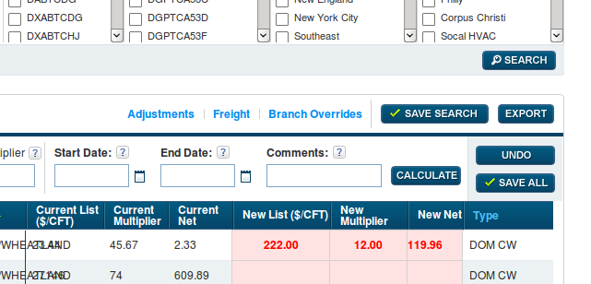

Then click 'Undo', you can see that all you input have been ignored

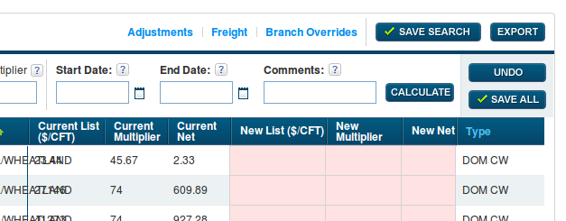

MyPricing
  - After you save some data into database
A pricing record will be created, you can back to 'My War Room' page to see it
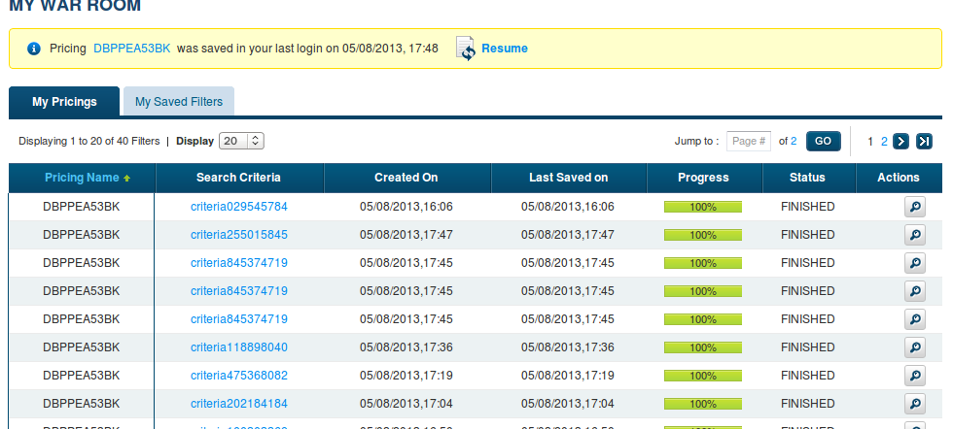

  - Let's create a new search filter
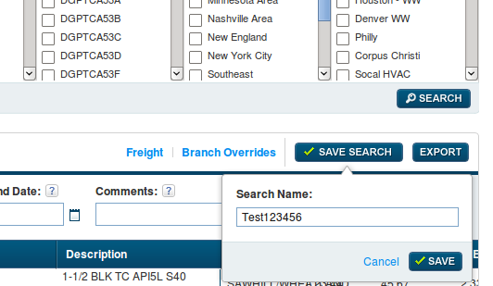
Then logout and login again, you can your last search filter and last pricing
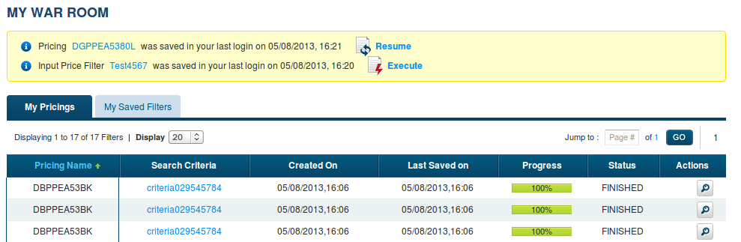

Lowest Net Price
Let's go to page 'Search', I select 'Dom CW', 'DGPPEA5380J', 'DGPPEA5380L', and 'DGPPEA5380K', the result page should be like this:
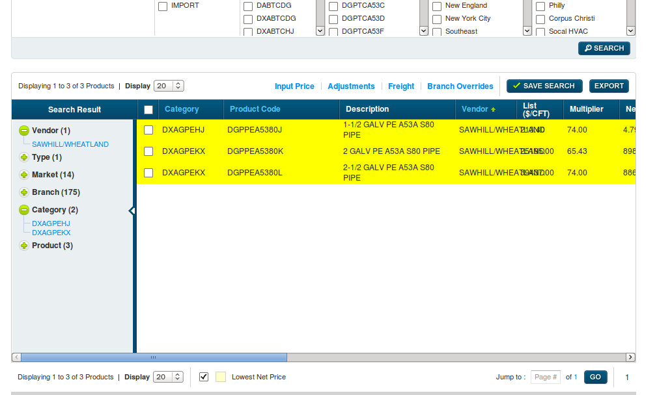

There is a checkbox near 'Lowest Net Price', unselect it, it will show all records
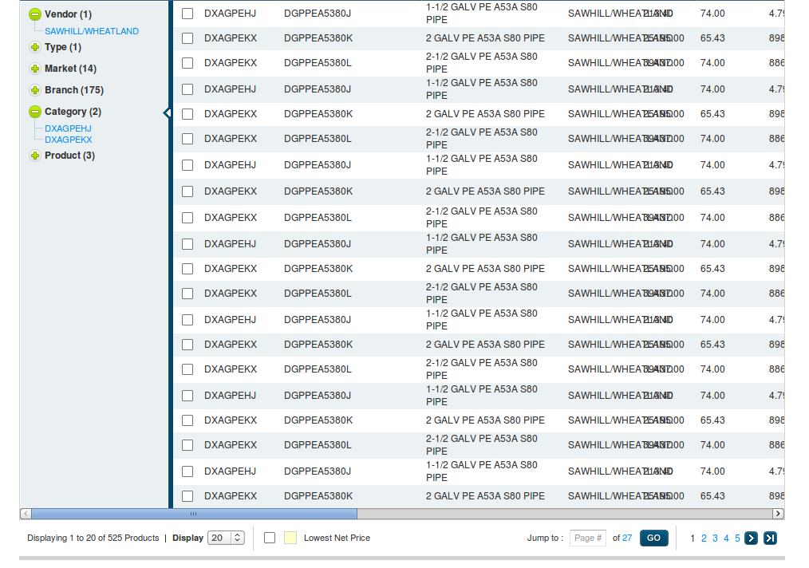

Saved Filters
Logout and login as another user, ex: (tfoster/WRuser321),
Switch to user page, you can see all 'saved filter' create by 'user' also can be seen.

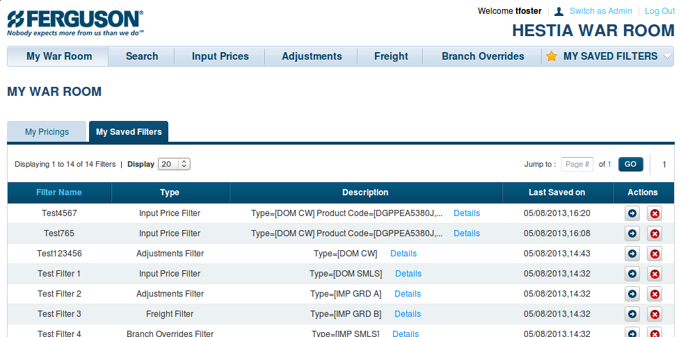

UI Updated
You can go any page to see search panel to see updated UI
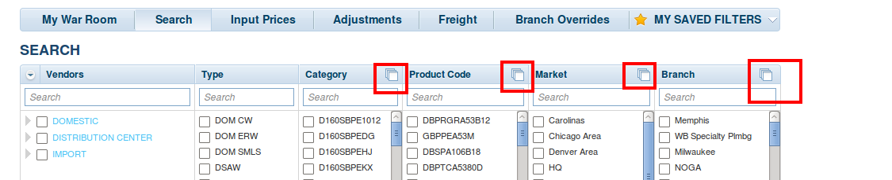

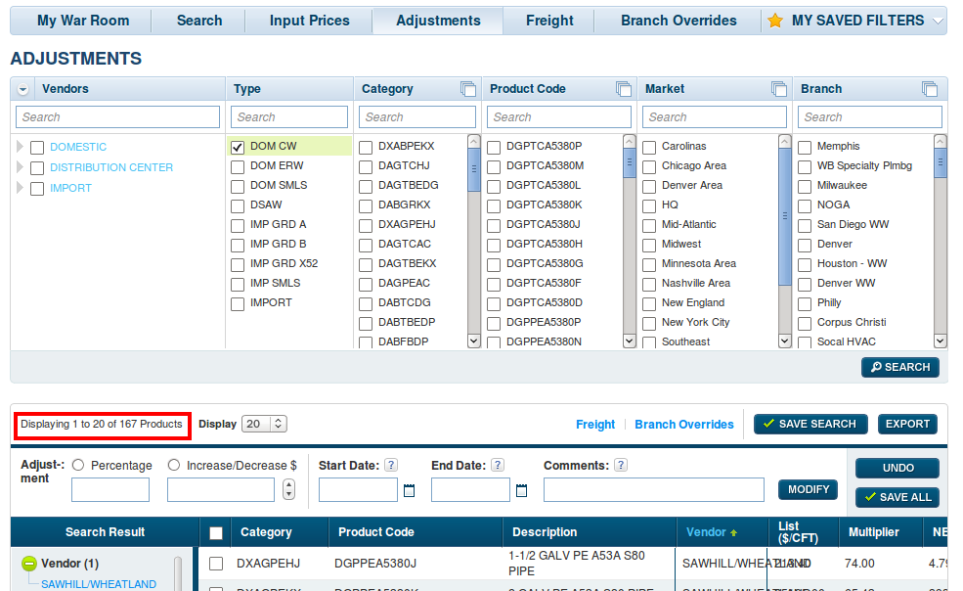
Adjustment
Go to page 'Adjustment', select 'Dom CW', then you can see 167 results.
This is same as page 'Input Pricing'

Resource Contact List

Name | Resource Email

